Online Exam System:-

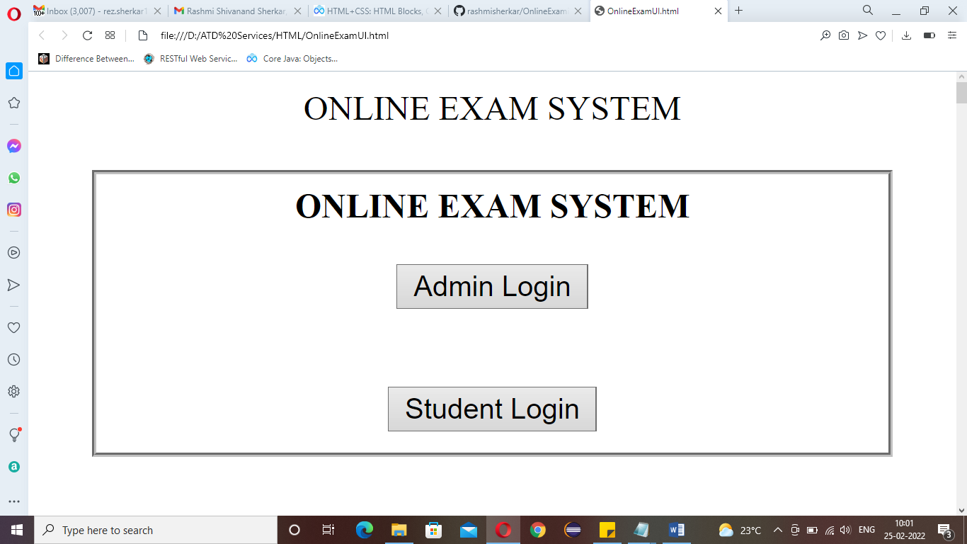

Admin Login After clicking on Admin login button it will display Admin login form

Student Login After clicking on Student login button it will display Student login form

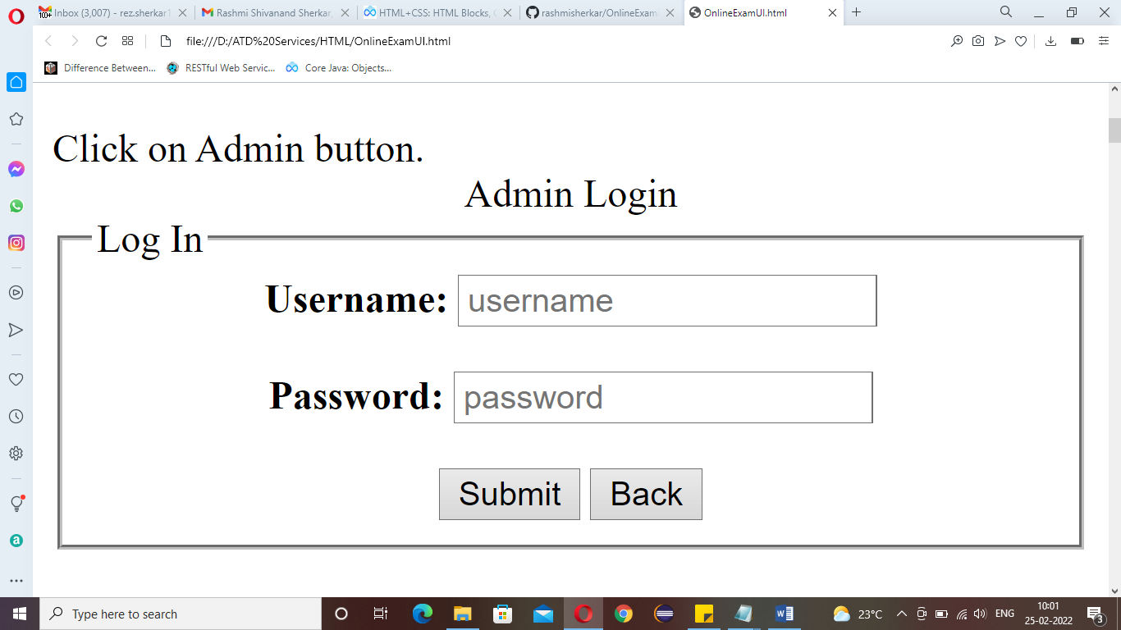

Submit Onclick Submit button it will open Admin section page

Back Onclick Back button it will goes to landing page

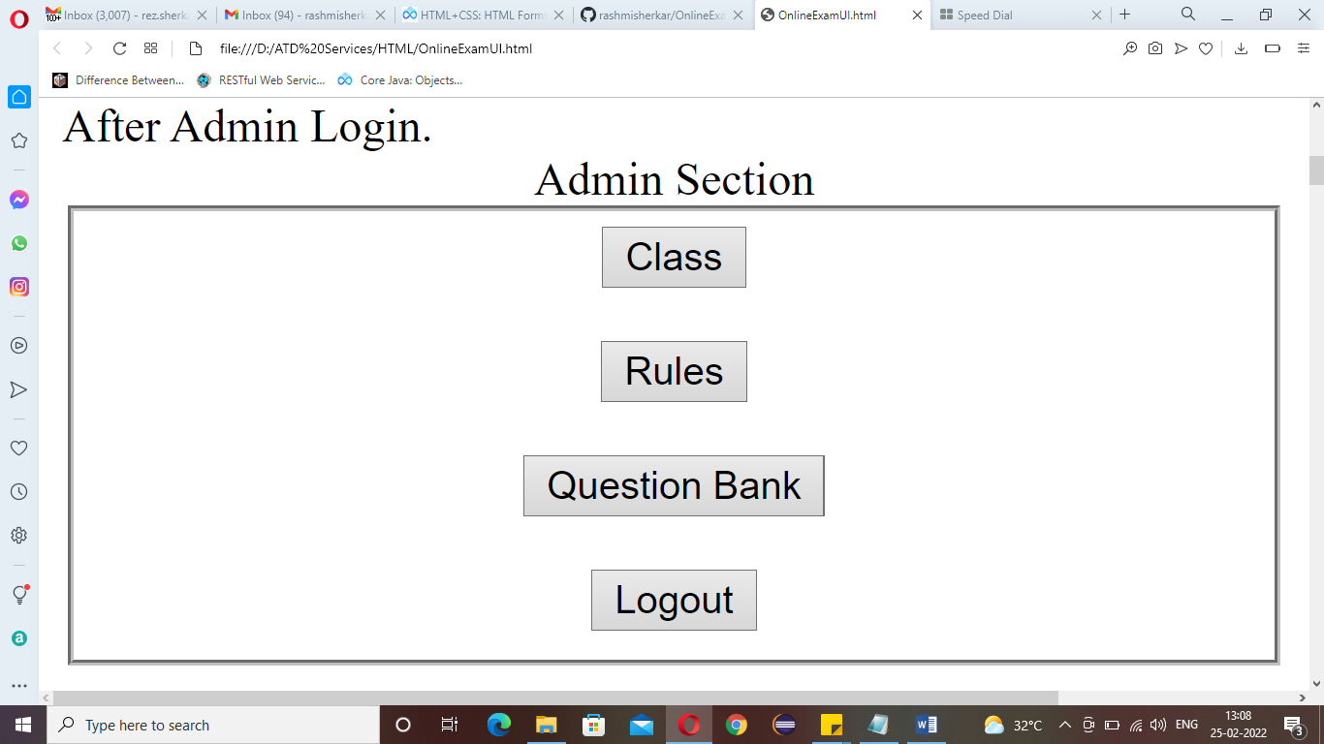

Class Onclick Class button it will open Class page

Rules Onclick Rules button it will open Rule page

Question Bank Onclick Question Bank button it will open Question Bank page

Logout Onclick Logout button it will goes to landing page

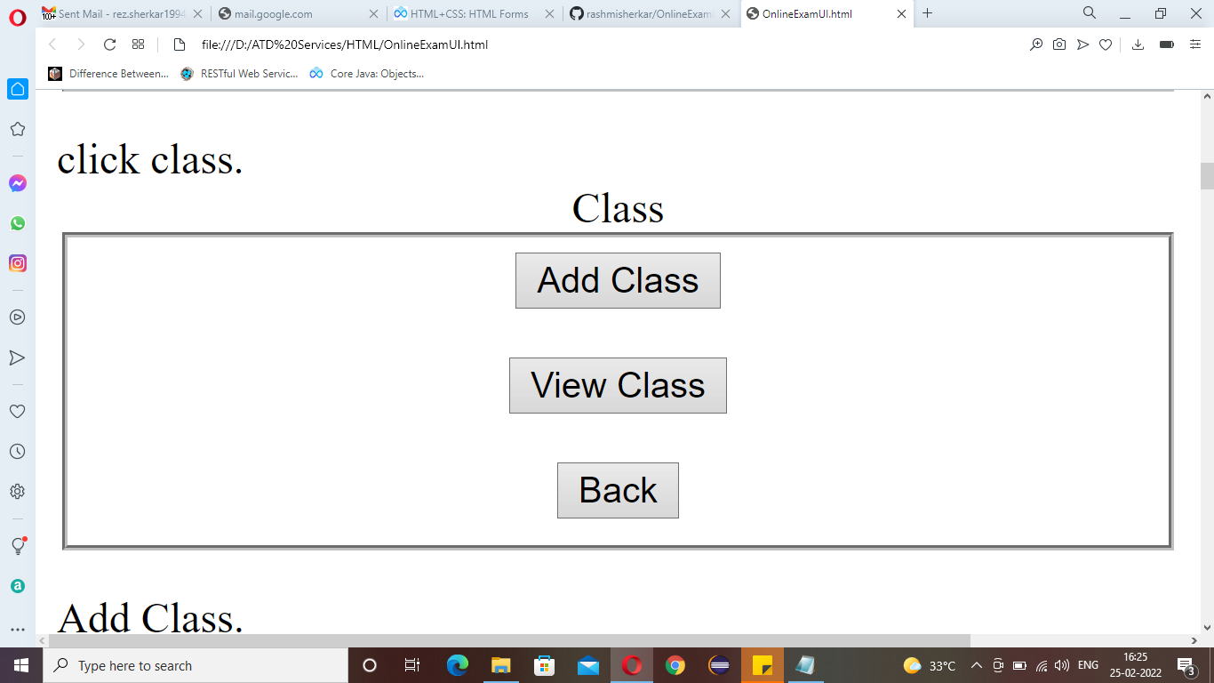

Add Class Onclick Add Class button it will open Add Class form

View Class Onclick view class button it will display Class details from class table

Back Onclick Back button it will goes to Admin section page

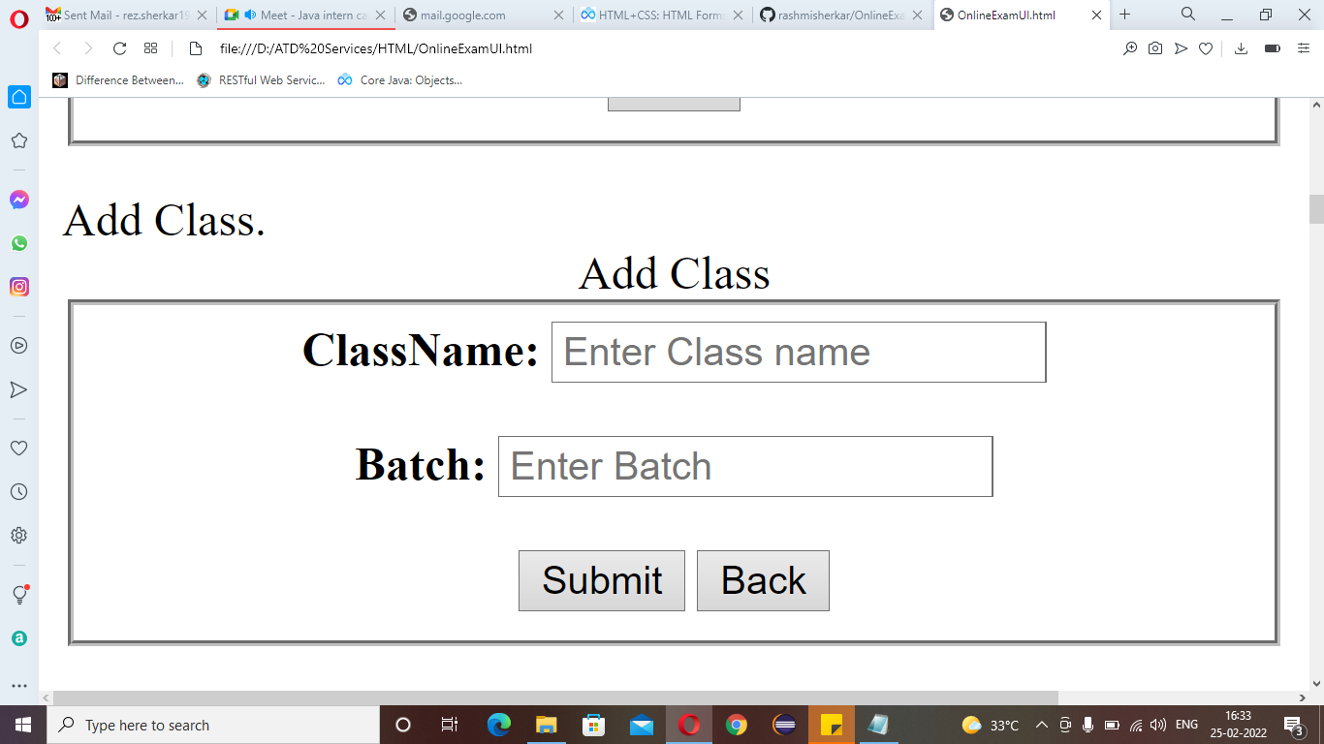

Submit Onclick Submit button it will add class details into calss table

Back Onclick Back button it will goes to Class page

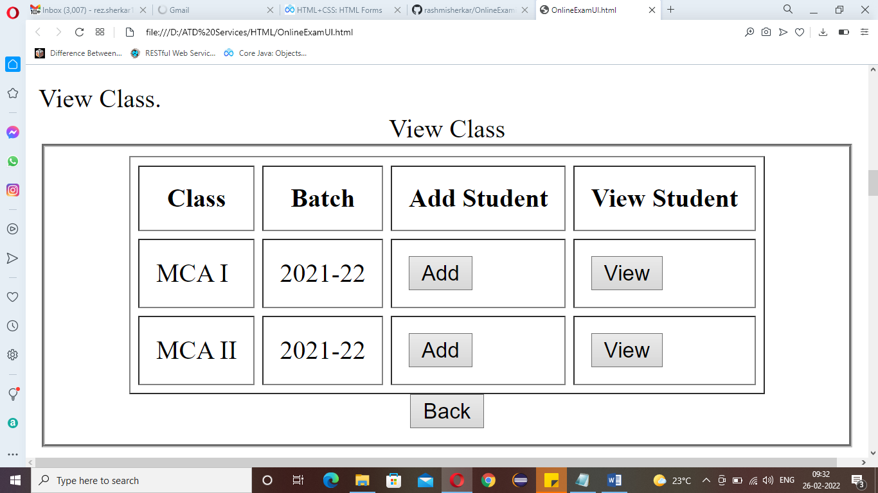

Add Onclick Add button it will open Add Student form

View Onclick view button it will display Student details from Student table

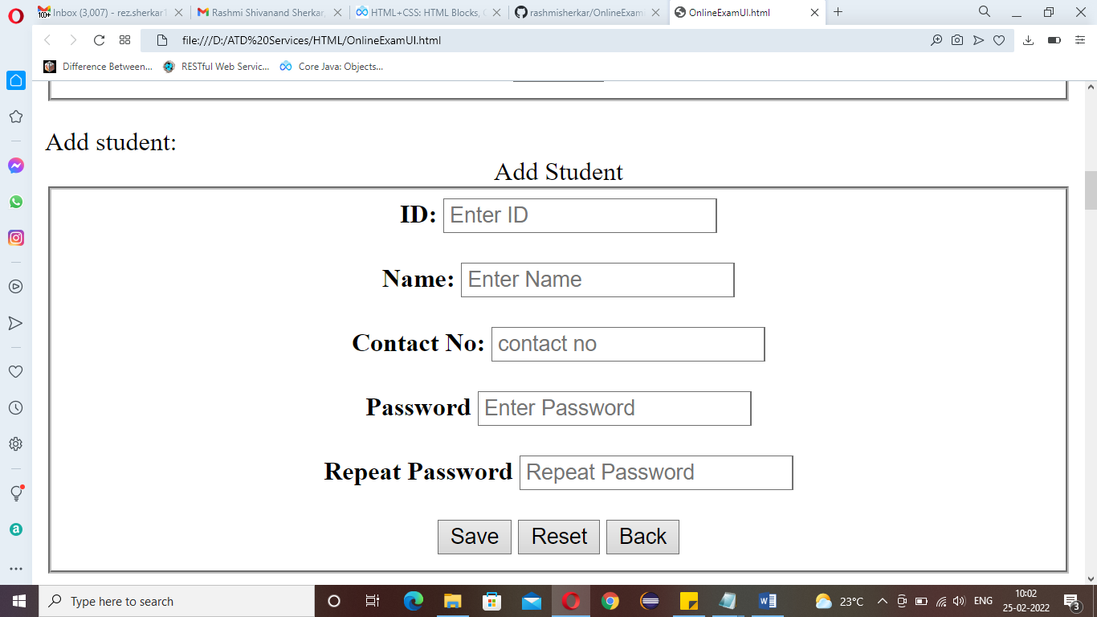

Save Onclick Save button it will add student details into student table

Reset Onclick Reset button it will clear all text boxes on this page and allowed to re-enter again

Back Onclick Back button it will goes to Class page

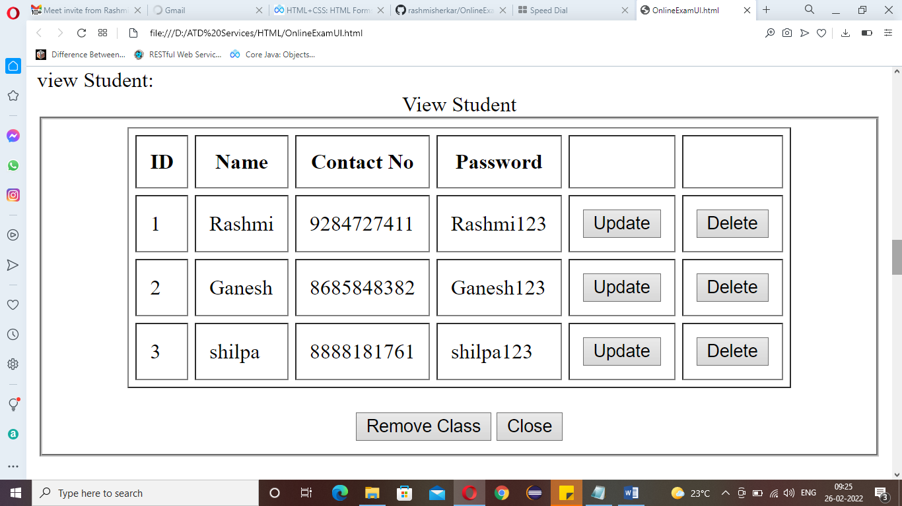

Update Onclick update button it will open update form

Delete Onclick Delete button it will delete that specific record from student table

Remove class Onclick Remove class button it will remove Class

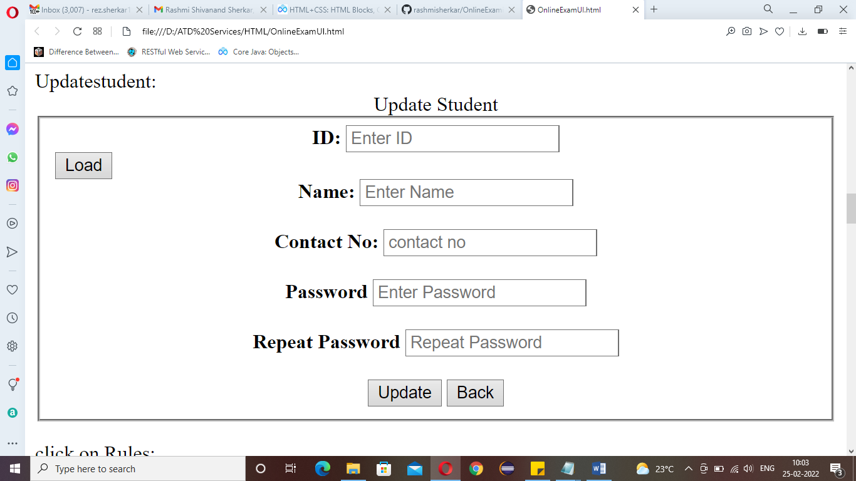

Update Onclick update button it will update student details into student table

Back Onclick Back button it will goes to view student page

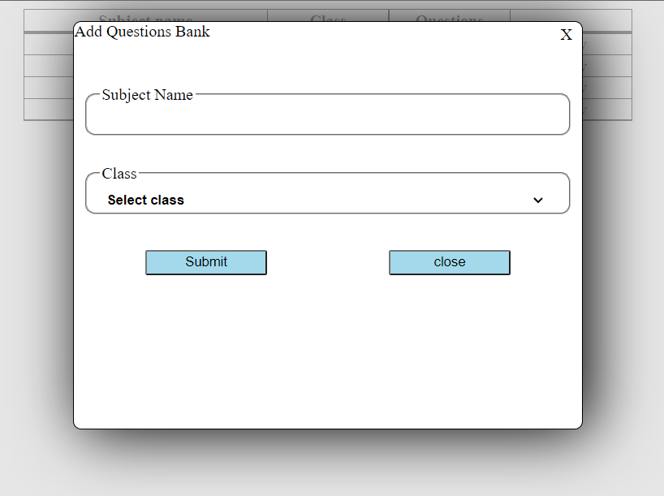

**Submit —>** Onclick submit button it will the add subject details

**Close   —>** Onclick close button it will close the window.

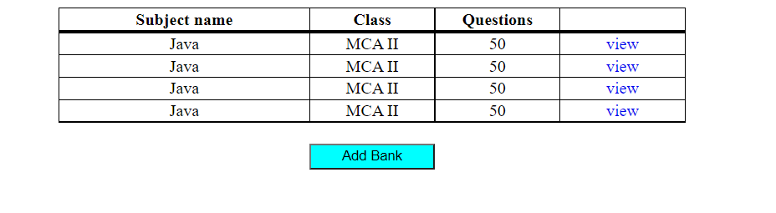

**Add Bank —>** Onclick Add Bank button it will open QuestionBank form

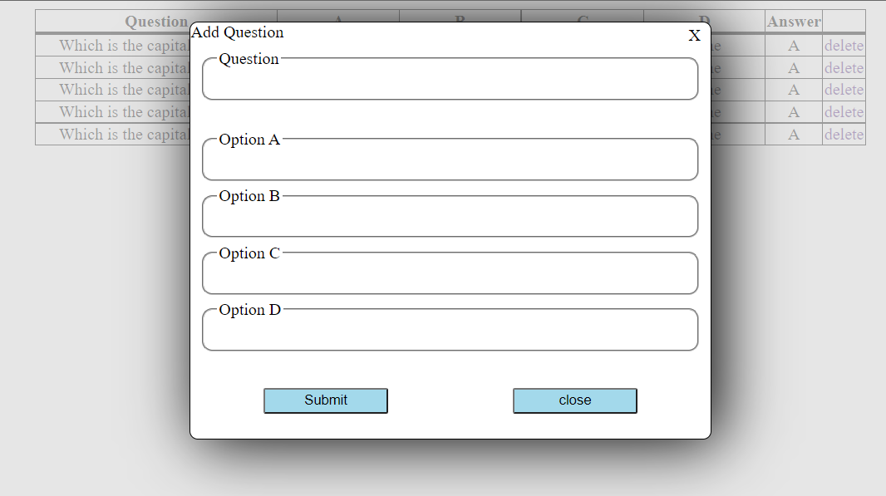

**Submit —>**  onclick submit button it will addnew question into the question bank

**Close   —>** onclickclose button it will close add question window.

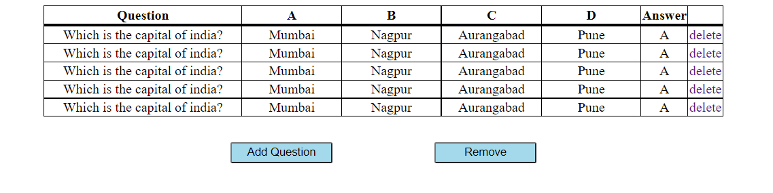

**Add Question —>** Open add question window to add new question.

**Remove          —>** onclickremove button it Send request to  to remove the opened question bank.

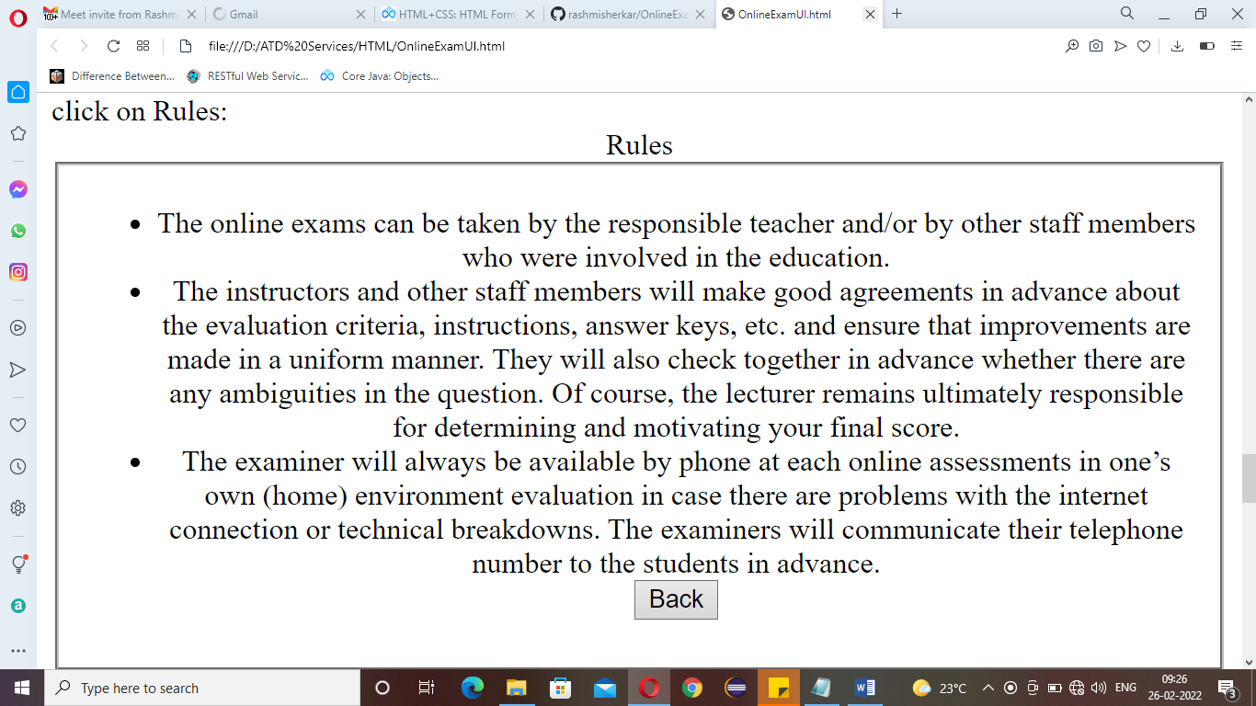

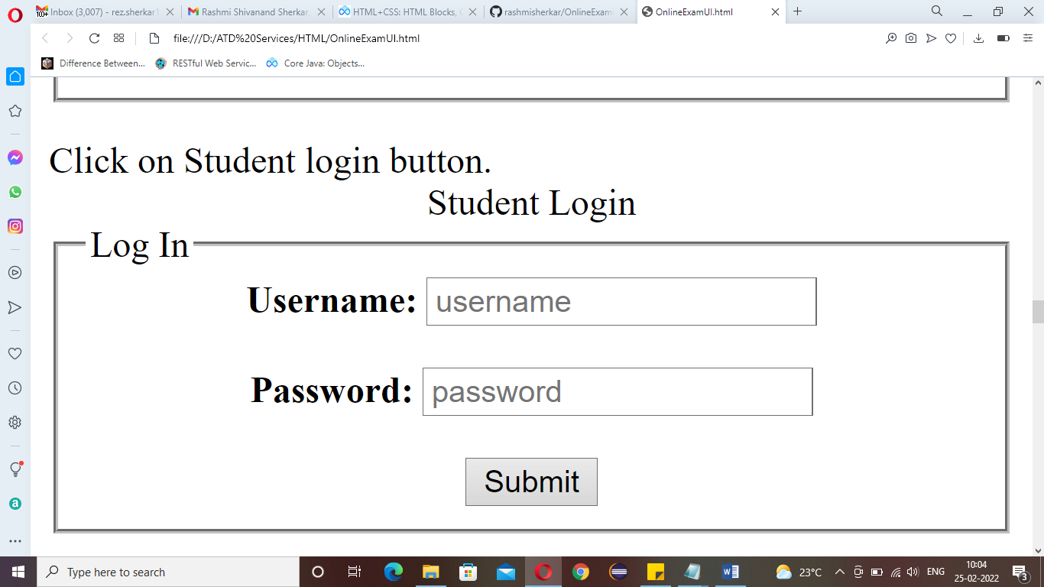

Submit Onclick Submit button it will open Student section page

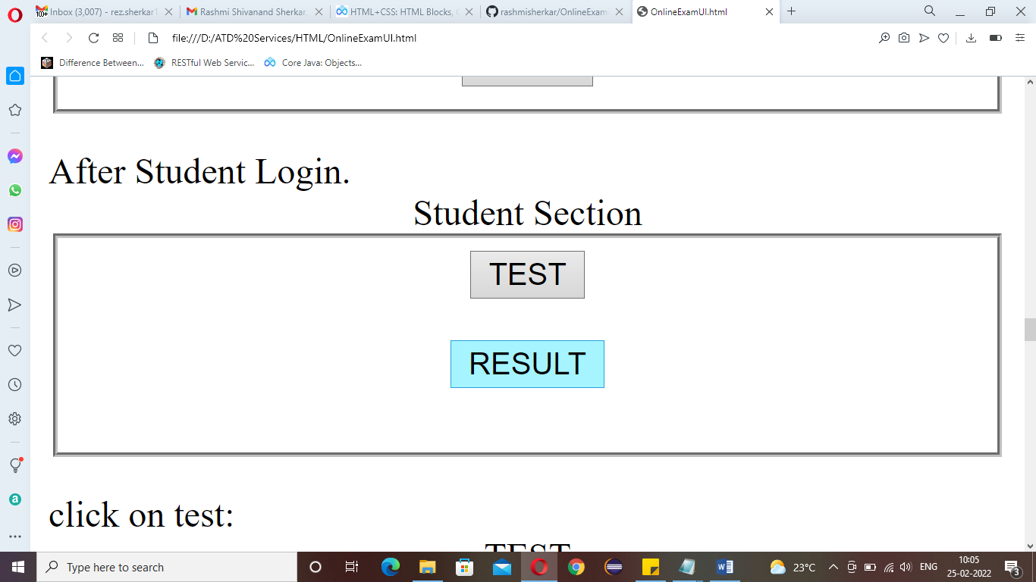

Test Onclick Test button it will open Test page

Result Onclick Result button it will open Result page and shows the result as per student Id

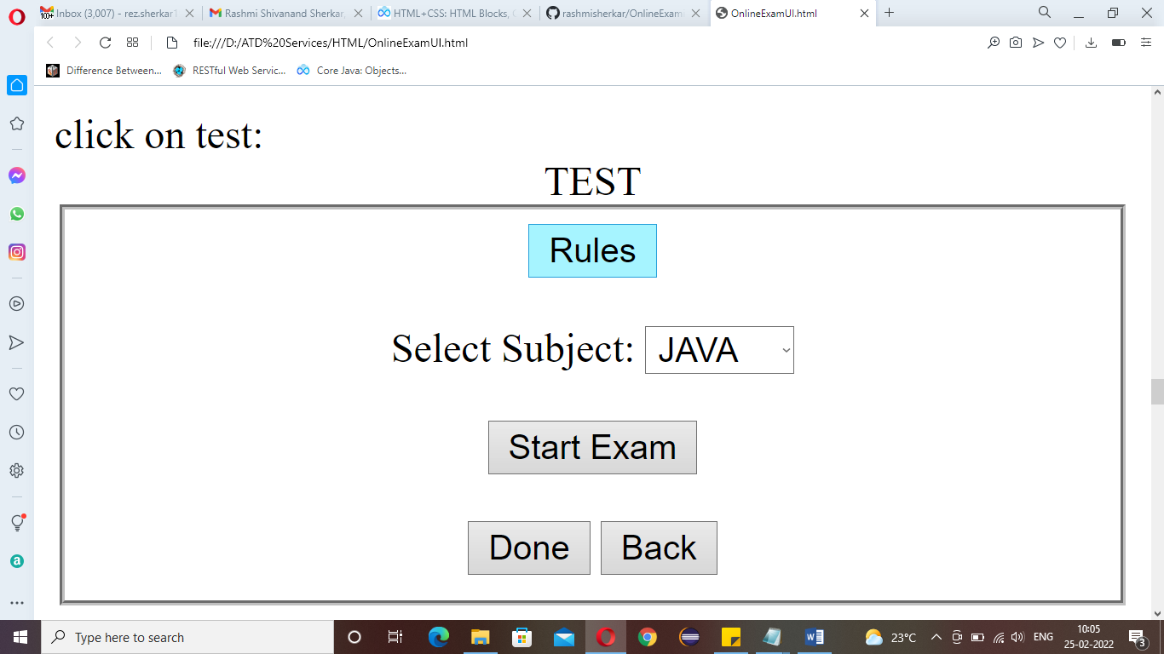

Rules Onclick Rules button it will display rules of the exam

Start Exam Onclick Start Exam button it will start the exam and open test window

Back Onclick Back button it will goes to Student section.

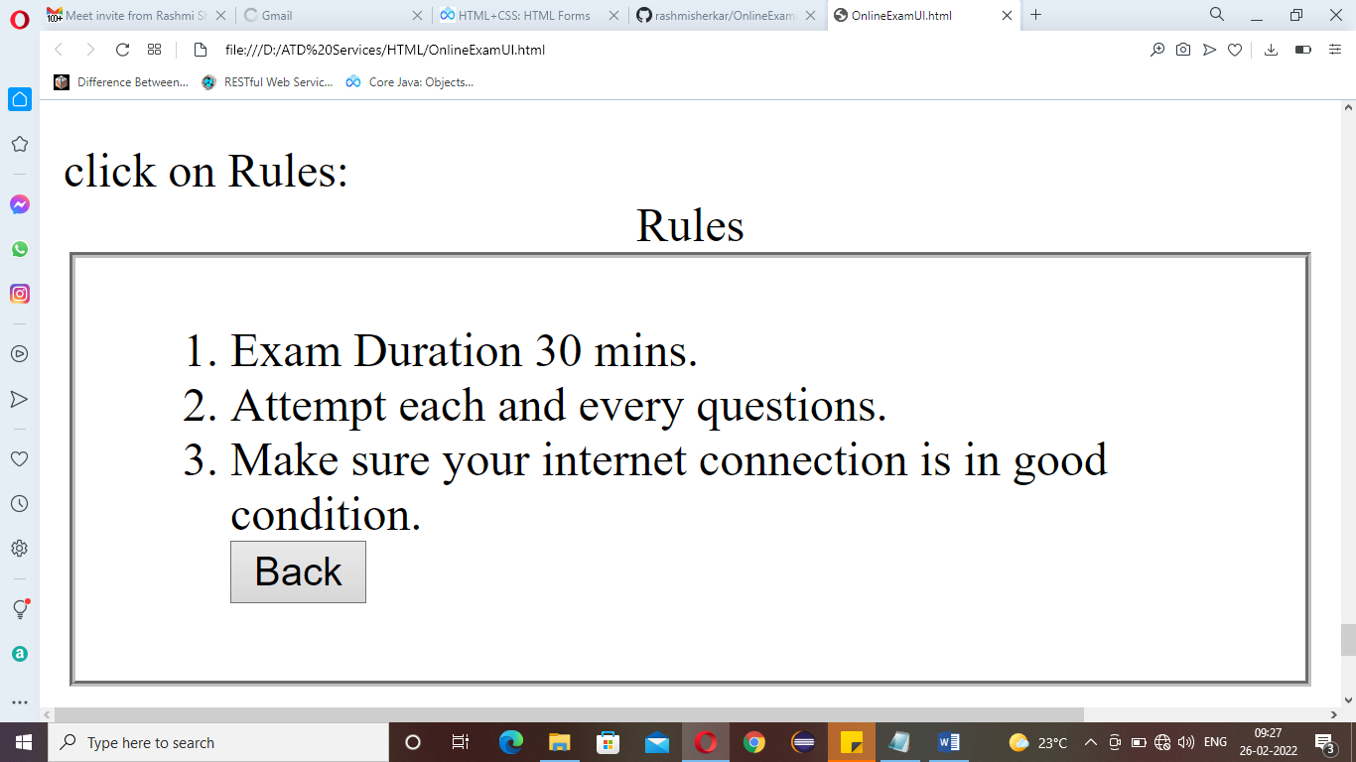

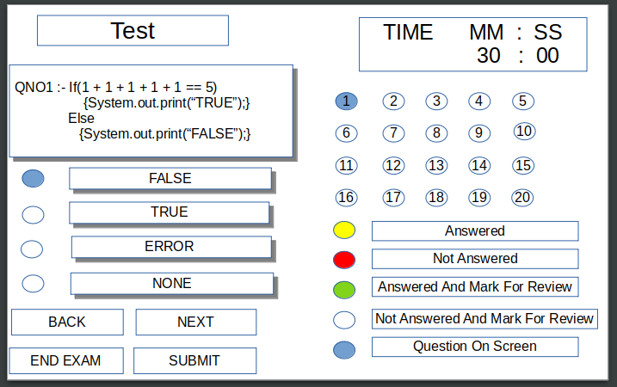

Submit Onclick Submit button it will submit the answer into answer table

Back Onclick Back button it will shows previous question

Next Onclick Next button it will shows next question

End Exam Onclick End Exam button it will end the exam and store data into question answer table with student Id

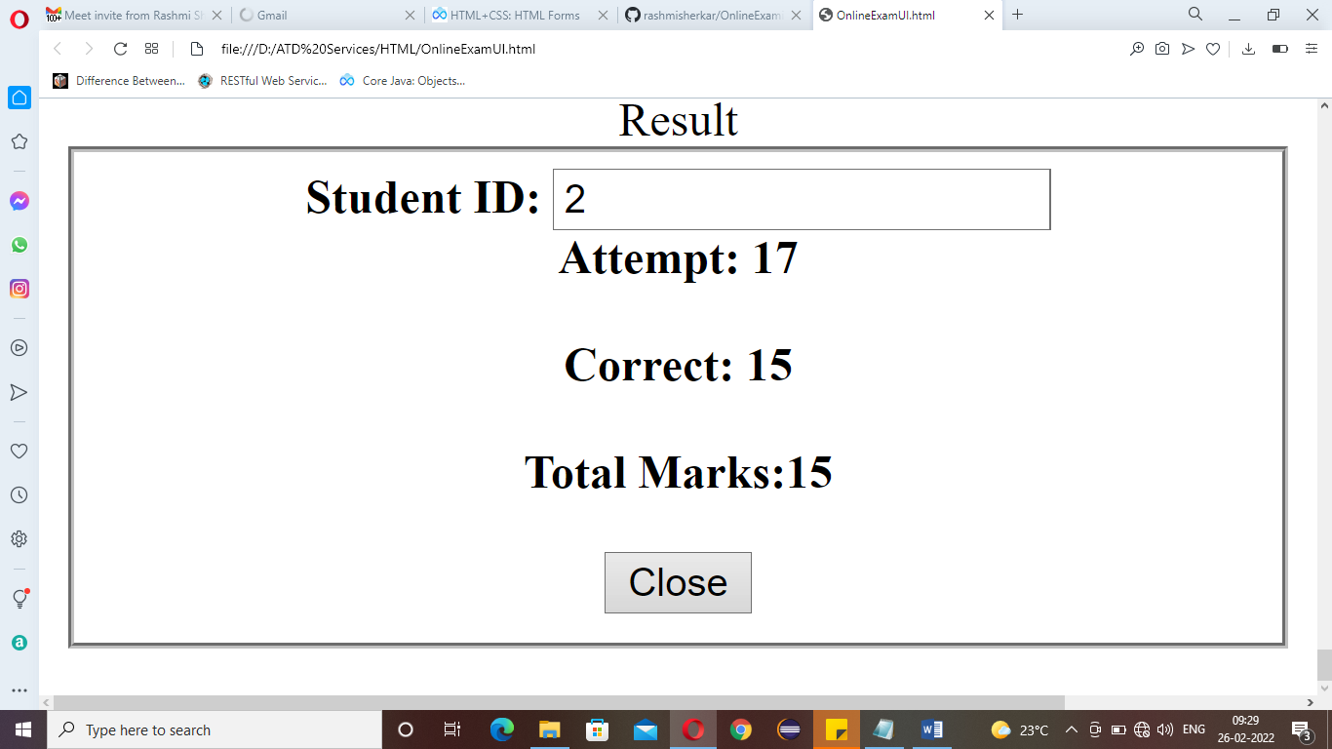

close Onclick close button it will close Result window